Raising Public Awareness and Reducing Marine Litter for Protection of the Black Sea Ecosystem LitOUTer

BSB-785

GAT1. State of art of marine litter pollution in partner countries

GA T1.2 Determination of habits/traditions/culture on the marine litter problem in local/national level

GA T1.2.1 Reaction of the public on litter and litter problems

Project Duration 1.07.2020/31.12.2022

First Progress Report Duration : 1July 2020-31 October 2020
Contibutors of The Report

Project Partners | Contributors
Lead Partner (PP-1) KTU | Assoc. Prof. Dr. Coşkun ERUZ
 | Prof. Dr. Fatma TELLİ KARAKOÇ
 | Prof. Dr. Hacer SAĞLAM
PP2 IBEDC | David TSISKARIDZE
 | Khatuna CHIKVILADZE
 | Tsitsino TURKADZE
 | Maia JOLOGUA
PP3 MN | Anca-Maria GHEORGHE
 | Mihaela Elena MIREA CANDEA
 | Angelica Ionela PAIU
PP5 NIMRD | Elena Stoica
 | Vasile Patrascu
 | Mariana Nicoara
 | Galatchi Madalina
PP6 BSNN | Emma GILEVA
 | Sabira STAHLBERG
 | Mihaela KOZOVSKA

CONTENT

SUMMARY 4
1. GENERAL INFORMATION 5
2. TURKEY 8
3. GEORGIA 23
4. ROMANIA 29
5. BULGARIA 30
5.1. Reaction Of The Public On Litter And Litter Problems. 31
5.2. Stakeholder Identification And Mapping. 32
5.3. Awareness and acknowledgement of the issue by the stakeholder groups 34
5.4. Perceptions On The Abundance And Location Of Marine Litter 35
5.5. Perceptions of the causes and consequences/risks of marine litter 36
5.6. Perceptions About Responsibilities And Involvement In Solutions To The Problem 38
CONCLUSION 39
REFERENCES 41

SUMMARY

This report presents the Black Sea NGO Network (PP6) baseline assessment of Bulgarian stakeholders’ state of awareness about marine litter, based on expert opinions and the findings of some surveys and other tools employed over the years by the partner organization. The assessment includes an account of experience and projects implemented and a review of societal engagements and attitudes to the marine litter problem, as well as summary of marine litter related activities and the related messages to the Bulgarian public conveyed by the communication channels, traditional and social media and publications.

The report focuses on perceptions about the nature, causes and consequences of marine litter, the perceived risks to the marine environment, human health and economy, the responsibility for the problem, and the prospects and means for its solution. It provides an analysis of trends across participating stakeholder groups in Bulgaria. The central aim of this review is to assess the intentions of stakeholders to engage in potential solutions to the problem.

The accumulation of marine litter on the beach as well as along the coast and in the sea has been clearly recognized as a problem in Bulgaria since the mid 1990ies. At the time it has been described as pollution with solid waste and has been the focus of International Black Sea Day awareness beach cleaning campaigns. Later Blue Flag and Coast Watch provided support and over the past ten years there have been quite a number of EU and national level projects and campaigns raising awareness on marine litter (the term has been used since 2008 with the start of implementation of the EU Marine Strategy Framework Direction MSFD) and also clean-up campaigns for the coast and citizen science campaigns on national and basin level. The coverage of marine litter issues and plastics pollution has been part of the mainstream of traditional and social media for the past few years. The Bulgarian stakeholders and especially people living along the coast clearly recognize marine litter and plastics pollution as a problem not only on local and national but also on basin and trans-border level. The awareness of people living in places far from the coast has also improved considerably, due to media coverage and national clean-up campaigns and plastics pollution reduction campaigns.

Location and abundance of litter on beaches and along the coast is most visible and the public is aware of it. Details on floating litter, litter in the water column and on the seafloor emerge not very often but awareness is improving. Underwater videos, cleaning of the seafloor and sea space of ports from litter improve awareness. They are reported as part of various awareness campaigns. Information on microplastics in sea waters and images or videos of microscopic is not very less

The public in Bulgaria is aware of most of the sources of marine litter especially those related to beach goers, cafes and bars on the beach, tourism and recreational activities. It is less well aware of pollution with litter from shipping, ports and fishing. Issues related to waste management and practices related to the hierarchy of waste are not always easy to understand by the public. The knowledge of the pathways and distribution of litter is growing, to a considerable extent due to the support from environmental education activities, media and NGO involvement. Beach litter monitoring, especially with innovative methods of reporting like the Marine LitterWatch app of the European Environment Agency (EEA) has contributed to the understanding of the sources, pathways and distribution of litter.

Responsibilities and solutions to the marine litter problem are the real challenge of raising awareness among Bulgarian stakeholders. This is surely the case with stakeholders in the partner countries as well. The changes in policy and personal behaviour would turn intentions into solutions and there may be different trends across participating stakeholder groups and littoral countries.

GENERAL INFORMATION

Marine litter pollution is an universal problem. Accumulation of solid wastes on the land and in the sea had been started from settlement of the cities since the ancient times. The dimension of the marine litter pollution has increased in line with the industrial development and changing of the habits of consumers towards industrial products. The main aim is to increase shelf life of the products to be ready to use in all seasons and transport to long distances in safe packages. Majority of these products and old goods are not degradable causing litter pollution in small or large extent. Cumulative impact of them has become a serious pollution source of the terrestrial and marine environment today. Especially, due to cheaper and easy manufactured goods made from plastics are widely used in daily life. Therefore, the volume of pollution is very huge and destructive for the nature. There are many actions has been carried out for reduction of the solid wastes on the land and marine litters in the sea. Some of them are;
1. identification of the landfill areas to undercontrol the solid wastes in certain locations,
2. classification of solid wastes and recycling,
3. obligation for the waste treatment facilities for all industrial plants,
4. obligations for permission from the relevant authority to discharge to special coastal filling areas,
5. collection of the solid waste from cities, villages and other settlement areas under the control of local authorities.

The reason of all these actions and others are implemented to reduce litters from the sources. Many of these methods have been used for a long time to save our environment. In this project, we will identify other solutions to reduce uncontrolled litters either at the source or in the last destination which is the sea bed. Some of the new methods and ideas could be suggested for reducing litters are;
1. to increase the frequency of the collecting solid wastes,
2. to start the classification and seperation of litters at home and continue these procedures till the storage areas,
3. to raise the public awareness on wider extent (methodology of the rising awareness of the public will be explained in the other GA implementation),
4. to clean marine litters from sea bottom periodically by dredgges and specialy designed vessels,
5. to trace transportation and determine the accumulation areas of the marine litters in the sea by using hydrodynamic-litter models.

The output of the project will be disseminated to wide range of population by organising workshops and symposium. Each workshop will consist of the outputs of the previous activities. Each country will organise two workshops. The number of participants will preferably about 50 persons each which composed by students, muhtars, housewives, villagers, citizens, religion person (imam, priest) decision makers, legal authorities etc. An international symposium will be organised in Turkey together with partners, scientists, decision makers and stakeholders at the end of the project. Symposium abstract book will be produced and published in the project website and pressed as hardcopy.

Marine litter has been recognized as a global issue raising grave concerns over the state of the marine and coastal environment. The potential damage caused by marine litter is complex and can be divided into three major categories including ecological, social and economic impacts. This complex transnational problem has been addressed by a number of regional interventions among them the project “Raising Public Awareness and Reducing Marine Litter for Protection of the Black Sea Ecosystem” (LitOUTer) promoting common awareness-raising and joint actions to reduce river and marine litter among four Black Sea countries. The project has been supported by the Joint Operational Programme Black Sea Basin 2014 – 2020. Lead partner is the Karadeniz Technical University, Marine Science Faculty, Trabzon, Turkey and partners are the International Business and Economic Development Center (IBEDC), Georgia, Mare Nostrum NGO, Romania, the Institute of Oceanology – BAS, Bulgaria, the National Institute for Marine Research and Development “Grigore Antipa”, NIMRD, Romania, and the Black Sea NGO Network, Bulgaria. The consortium of NGOs, higher education and scientific research institutes from four countries employs innovative awareness raising methods including information exchange, education and training and demonstration of litter movements by GIS web-based hydrodynamic model. The project will be implemented in the course of 30 months and the overall project budget is about 930 000 euro.
The project enhances awareness-based neighborhood cooperation through national level and cross-border initiatives on raising the awareness of societies about the sources and distribution of marine litter and supporting policies and tools leading to marine litter reduction. This report provides an overview of Bulgarian stakeholder awareness and attitudes to the marine litter issue and the wider awareness of waste management and problems associated with it. The report will service the development of specific tools suitable for awareness raising for the targeted stakeholder groups in Bulgaria. It will help reach the correct target groups with the correct messages to produce strong impact for marine litter reduction at the source.

- TURKEY
Marine litter (sometimes called marine debris) is any persistent, manufactured or processed solid material which is discarded, disposed of or abandoned in the marine and coastal environment. Marine litter consists of mostly very slowly degradable waste items such as plastic, polystyrene, metal and glass. Marine litter is found on the beaches and shores, on the water surface, in the water column and on the seabed. It can be found near the source of input but also be transported over a long distance with sea currents and winds.

Marine litter causes marine environmental, economic, health and aesthetic problems, including possible transfer of toxic substances and invasive species, destruction of marine habitats and loss of biodiversity. It also threatens marine life through entanglement, suffocation and ingestion as well as poses a risk to human health and life.

Marine litter originates from sea-based activities and from land-based activities, which represent the main sources of marine litter production. It covers any solid material which has been deliberately discarded, or unintentionally lost on beaches and on shores or at sea, including materials transported into the marine environment from land by rivers, draining or sewage systems or winds. Among the sea and land-based activities are including littering actions in coastal areas. Different studies and surveys have shown clear evidence that plastic is the largest type of marine litter. Other abundant types include packaging material, smoking related material, and fishing material. Several factors can possibly explain the marine litter originating from tourism related activities. The local context has a direct influence on the production of marine litter through parameters such as the cleanliness of the area and local people’s behavior, and the availability of facilities for litter disposal and clear instructions on waste disposal. There are also social reasons like the lack of awareness about littering and its impacts.

As a result of the presence of marine litter, there are a wide variety of short and long term adverse environmental impacts to individual organisms, species and ecosystems as a whole. Marine litter can damage benthic environments, cause a loss of biodiversity and lead to a reduction in overall ecosystem function. Enhanced awareness and deepened understanding of the issue of marine litter are crucial for catalyzing change in the perceptions and attitudes of the different stakeholder groups, including the wider public, towards more informed decisions and responsible individual behavior.

We’ve picked some of the campaigns from Turkish Black Sea Shores with our communities between 2009-2020. Communities , NGO’s, Municipalities, National associations etc. organize clean-up facilities of their local areas. Some clean-up activities for the local awareness done in the field are listed below.

- More than 65 thousand tons of marine litter were collected from the sea and coasts with 'Zero Waste Blue' project- 7.6.2020

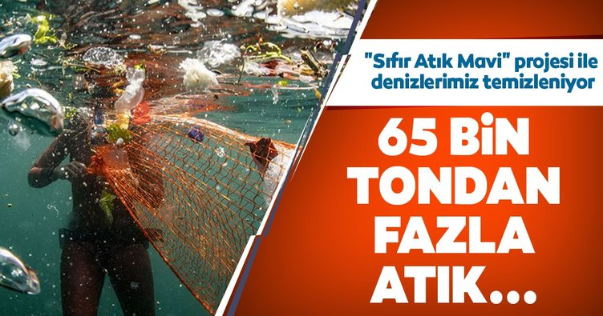

Clean-up marine and water resources in Turkey was started under the project is called "Zero Waste Blue". In this project, 250 tonnes of waste was collected from the coastal areas. In the studies were conducted within the scope of the project started in June 2020, a maximum output of plastic waste and cigarette butts from the sea and the coast of Turkey. Turkey under Prime Minister Recep Tayyip Erdogan's wife Emine Erdogan, under the auspices of Environment and Urban Planning Ministry carried out by “the Zero Waste Project”, in order to prevent contamination with the protection of the sea and the presence of water on June 10, 2019 "Zero Waste Blue Project" was launched. Thus, action was taken to clean the sea and water assets throughout the country.
In this context, Marine Litter Provincial Action Plans were prepared in 28 provinces with coasts. With the action plans, areas and sources (beaches, rivers, activity areas and similar places) where marine litter is seen intensely were determined. In addition to efforts to reduce marine litter, cleaning activities have been initiated on beaches, on the sea surface and on the seabed to collect marine litter.

Later, the cleaning and awareness activities of the public gained momentum. Raising awareness and information activities were carried out by the Directorates of Environment and Urbanization, municipalities and non-governmental organizations, as well as various public service announcements and social media activities.

The scope of the project is to train 45000 people about zero waste Blue. AND 49000 tons of plastic waste collected from coastal areas. The second most predominant waste was cigarette butts.

Istanbul was one of the provinces that collected the most waste. Samsun, Antalya, Zonguldak, Kastamonu, Bursa, Kocaeli, Çanakkale, Balıkesir and Trabzon followed Istanbul respectively. Within the scope of Zero Waste Blue and action plans, sea surface, bottom and beach cleaning activities were carried out. Studies have been initiated for the transition to the Zero Waste System in hotels, marinas and ports on the seashore. In this context, efforts to establish Zero Waste System have started in 937 hotels and 60 ports and marinas.

Within the scope of the project, beach cleaning activities have been made more effective and the Blue Flag application, which is an indicator of clean seas, has achieved the greatest increase in recent years in 2020. The number of beach with Blue Flag rises to 486.

The number of environmentally friendly blue flag marinas where waste is collected separately at the source was 22 in 2020.

- Most marine litter in Turkey, came from Samsun, 26.02.2020

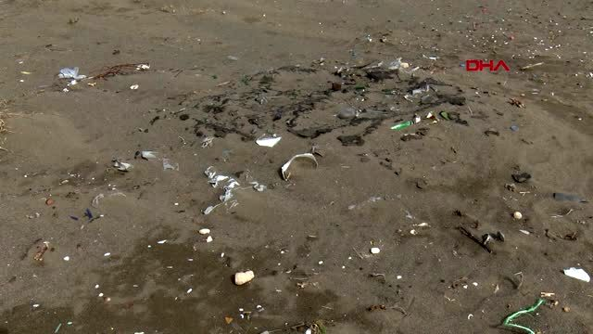

According to data from the Ministry of Environment and Urbanization, the most of the marine litter collected from the coast of Samsun Province was 58 thousand cubic meters in 2019. Samsun was followed by Istanbul with 35 thousand cubic meters and Antalya with 28 thousand cubic meters. Coastal cleanup activities were carried out in the city with the participation of volunteers of non-governmental organizations, officials of relevant units of public institutions and organizations, and representatives of non-governmental organizations. In the city, which has a 120-kilometer coastline, efforts were focused on collecting marine litter especially at the beaches where the citizens swim intensely. Most of the garbage that came out of the sea was plastic and aluminum items.

- Trabzon University Students And Akçaabat Municipality Cleaning Services Directorate Teams Cleaned The Market Place And The Coastal Park Together And Collected The Garbage At 13 December 2019.
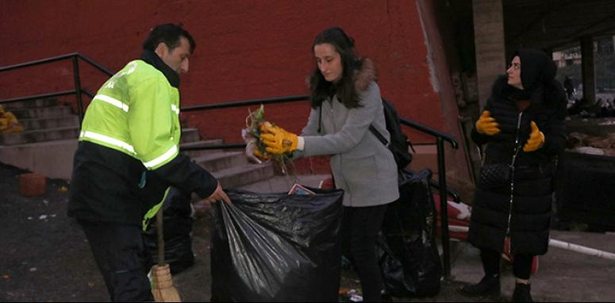

Senior students of the Department of Guidance and Psychological Counseling at Trabzon University Faculty of Education gave a hand in hand message for a clean environment by contributing to the collection of garbage in the Akçaabat Marketplace and the coastal park. Emphasizing social responsibility projects and environmental cleanliness, the students contacted the teams of Akçaabat Municipality Cleaning Works Directorate. Garbage was collected with the learners at the appropriate place and time by the Akçaabat Municipality Cleaning Affairs Directorate

- The Mayor Of Trabzon Put On Gloves And Cleans The Beach From Garbage, 13 October 2019
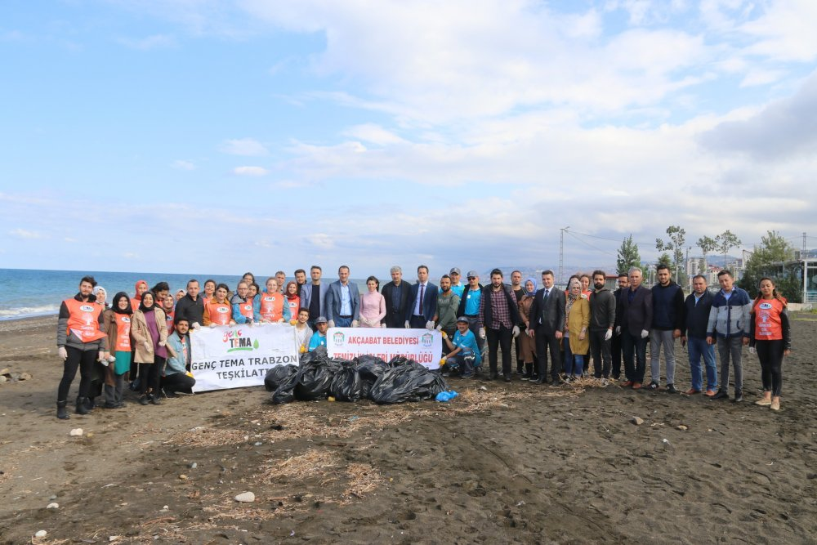
In cooperation with the Akçaabat Municipality Cleaning Affairs Directorate and TEMA Foundation volunteers, the garbage thrown on the beach was collected in order to create environmental cleanliness awareness. The garbage accumulated on the coast of Söğütlü neighborhood in the Akçaabat district of Trabzon was cleaned in cooperation with the Akçaabat Municipality Cleaning Affairs Directorate and TEMA Foundation volunteers. At the event attended by many volunteers, Mayor of Akçaabat Osman Nuri Ekim put on his gloves, took a garbage bag and collected the garbage one by one. Stating that they are organizing an event to clean up the waste on the beaches, Akçaabat Mayor Osman Nuri Ekim said, “This is the environment for all of us. In order to create awareness, we are trying to raise awareness of people by collecting the trash they have thrown away.

- They collected garbage on the beach accompanied by bagpipe (Tulum), 08.06.2019
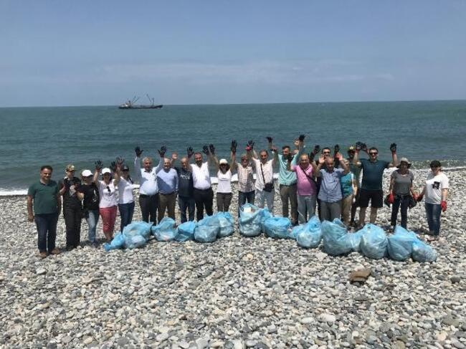
In the Iyidere district of RIZE, nature lovers carried out coastal and underwater cleaning on the beach accompanied by overalls. Recep Tayyip Erdogan University (RTEU), Fisheries Faculty, Technical Sciences Vocational School, Underwater Technology Department, Turkish Women's Council and Iyidere Municipality organized a garbage collection event at Sarayköy Beach, within the scope of June 8, World Seas and Oceans Day. In the event, nature lovers carried out coastal and underwater cleaning in the presence of local overalls. In the event, which aims to raise awareness about plastic waste and its environmental effects, RTEU Faculty of Fisheries Faculty Member Assoc. Dr. Ülgen Aytan stated that they wanted to draw attention to the bad effect of plastic on humans and animals on the World Seas and Oceans Day. Aytan said, "Marine litter is one of the biggest problems threatening the oceans and seas. The most prevalent of these is plastics, we use single-use plastics in every field in our daily life. Plastics reach the seas from various sources, especially terrestrial sources. They start to accumulate within the seas and souls. We encounter plastics in most of the fish we catch in the Black Sea. This is a global problem throughout the world. Our advice is to change our personal usage habits. Especially to remove the disposable plastics from our lives, to reduce the plastic as much as possible. Plastic is not bad, it is a miraculous product only, to use it correctly, to use it properly. "If possible, use it again is the right thing," he said.
'WE MUST TAKE PLASTIC OUT OF OUR LIVES'
Iyidere Mayor Saffet Mete also noted that they always supported such projects as the municipality and said, "When the event came to us, we supported it a little more. On the one hand, we need to think about it, it is the people who do this, that is, the people who pollute the nature. "We will develop these projects more together with our teacher and make our district a pilot district. We cannot completely remove plastic from our lives, but if we consume it consciously, we can reach better places."

- Volunteer Cleaning From Trabzon Sports Provincial Directorate Youth Center Youth.20.06.2019
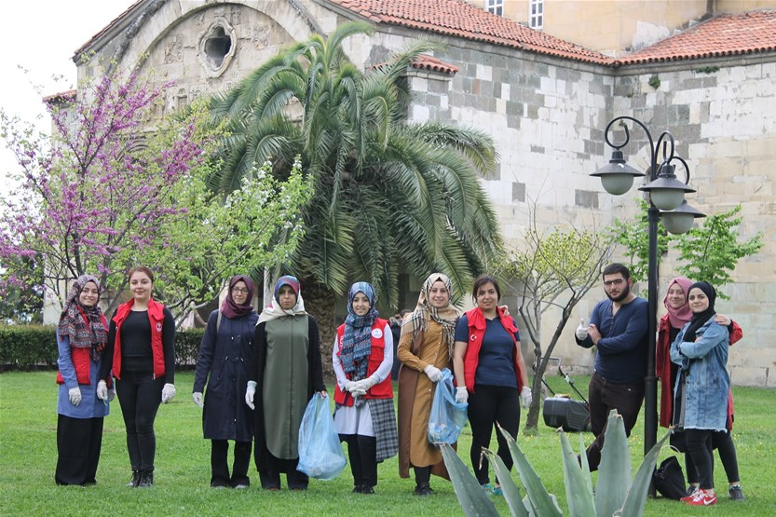
University students who are members of the Youth Center gathered on the beach of Beşirli, first cleaned up along the beach. The students, who collected everything from plastic bottles thrown irresponsibly on the beach with garbage bags to cigarette butts and papers, then went to Sera Lake, one of the natural paradises of Trabzon, and continued cleaning. The last stop of the youth was the Hagia Sophia garden.
Trabzon Youth Services and Provincial Director Birdal Öztürk pointed out that volunteer youth signed exemplary projects, and Yasin Aydın, one of the leaders of the Youth Center, said: “Trabzon is a beautiful city, but we are trying to pollute and destroy this naturalness with unconscious waste. Everyone should be mobilized to raise awareness in people, instill environmental awareness and protect nature ”.

- Zonguldak's Beaches Cleaned The Gendarmerie Teams And Citizens Under The World Environmental Protection Week. 11 Haziran 2020
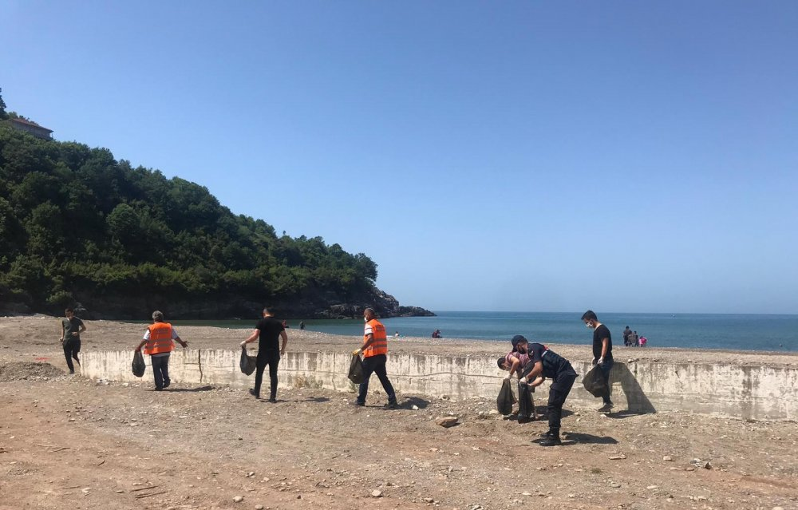
Göbü coast of Zonguldak was cleaned by gendarme teams and citizens within the scope of the World Environmental Protection Week in 2020
The diver team, citizens and students collected a large amount of waste material during beach and seabed cleaning within the scope of “Zero Waste Blue" project in 2019. During the cleaning of the seabed, 10 sacks of waste material, including vacuum cleaner, plastic bottle, plastic bag, glass, fishing line net, as well as a large number of automobile tires was removed (Figure 2).
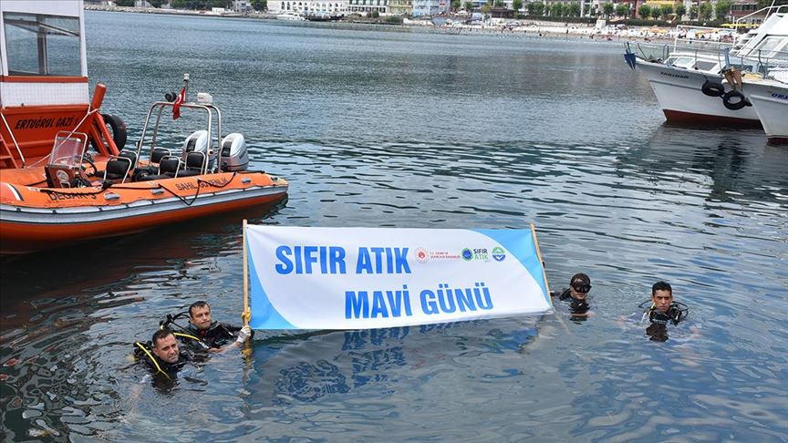
A total of 135 high school students from 12 schools cleaned the beach, which is about 1 kilometer, where vacationers intensively swim in the summer in 2019. Students filled the garbage such as tree branches, wood, plastic bottles, bags, syringes, broken glass and newspaper pieces into the bags in their hands in Zonguldak coast (Figure 3). The aim was to increase environmental awareness and contribute to “the zero waste” project.

- Bottom cleaning was done in the 'pearl of the Black Sea', 10.07.2019

In the Amasra district of Bartın, a large amount of waste material was collected during the beach and seabed cleaning with the participation of the divers, citizens and students.
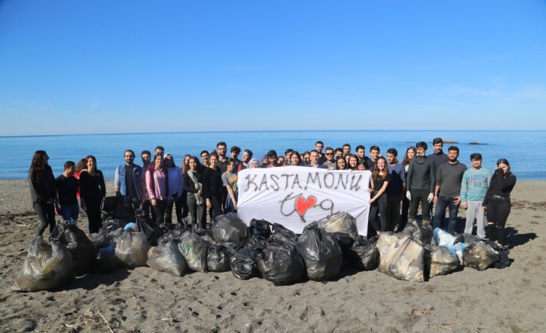
68 students from Kastamonu University Community Volunteers Foundation Community collected approximately 150 bags of garbage in the environmental cleaning they carried out on the Abana and Bozkurt beaches of the Black Sea in 2018. Working for a cleaner environment, the students ensured that the garbage they separated according to their type was recycled.

- Awareness movement on environment and cleanliness in Tekkeköy. 27.11.2017
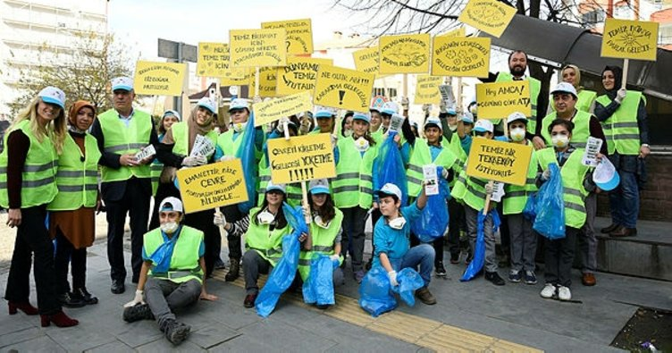
Tekkeköy Municipality and Tekkeköy Primary and Secondary School organized a march with the students, accompanied by banners, in order to raise awareness about environment and cleanliness in the district.
Samsun-Tekkeköy Municipality and Tekkeköy Primary and Secondary School organized a march with the students accompanied by banners in order to raise awareness about the environment and cleanliness in 2017 .

- Protect And Know The Sea Project, Was Held In Sumae, 27.10.2014
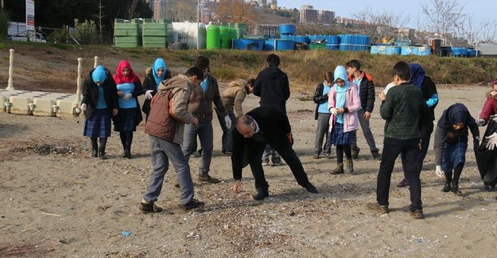
Within the scope of the "I Know and Protect My Sea" project, presentations about , the danger posed by litter to our sea and environmental awareness were made to the students of Imam Hatip Secondary School regarding the marine ecosystem by Central Fisheries Research Institute in 2015 .

- Turmepa Cleaned Atakum Beaches, 20.09.2014
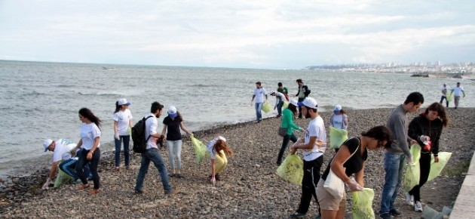
Students and volunteers in Samsun conducted beach cleaning by the sea simultaneously with the world within the scope of "International Coastal Cleaning Activity". TURMEPA Marine Clean Association International Coastal Cleaning Event, with the world ...
DenizTemiz Association (TURMEPA), students and volunteers carried out beach cleaning by the sea simultaneously with the world within the scope of the "International Coastal Cleaning Event". They collected glass, plastic bottles and papers thrown on the beach along the Samsun-Atakum coast in 2014 .

- A Visit to the Sea Ecosystem by the Students, 25 December 2015
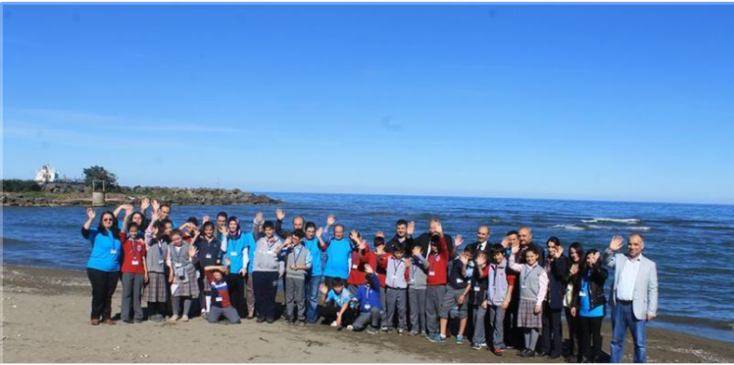
With the activity organized at the Aquaculture Central Research Institute within the scope of the "I Know and Protect My Sea" project, Bahçecik Imam Hatip Secondary School 8 F class students were given the activities of the institute by the Institute's Technical Staff in accordance with the examples in developed countries. and presentations on environmental awareness were made.25 December 2015
Within the scope of the "I Know and Protect My Sea III" project carried out in partnership with METU (Middle East Technical University), CFRI (Central Fisheries Research Institute), IU (Istanbul University) and DEU (Dokuz Eylul University), a practical garbage collection activity was held for secondary school students on the beach for environmental pollution in 2014 (Figure 8).
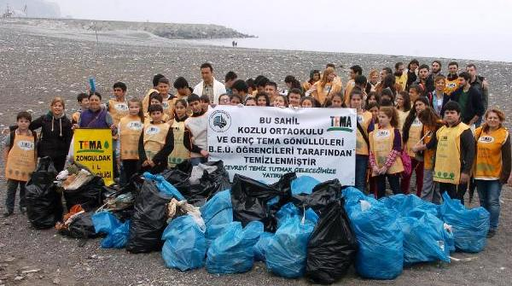
A total of 90 students from Bülent Ecevit University and Kozlu Secondary School attended the garbage collection event held by TEMA Zonguldak Provincial Office in Kozlu Beach in 2013. Students filled the garbage such as scrap parasols, syringes, broken glass pieces, pet and drink bottles, newspaper pieces, tires, socks, plastic pipes, diapers into bags. 55 bags of garbage collected during the 1.5-hour of operation were delivered to the municipality officials.

- Students Cleaned The Black Sea Coast, 07.05.2012

Düzce University, Akçakoca Vocational School students and Akçakoca Municipality staff cleared the beach from rubbish in 2012. Municipality staff and 80 students wore T-shirts with the text "More Clear Akçakoca" and raked out the garbage in Çuhallı Beach.
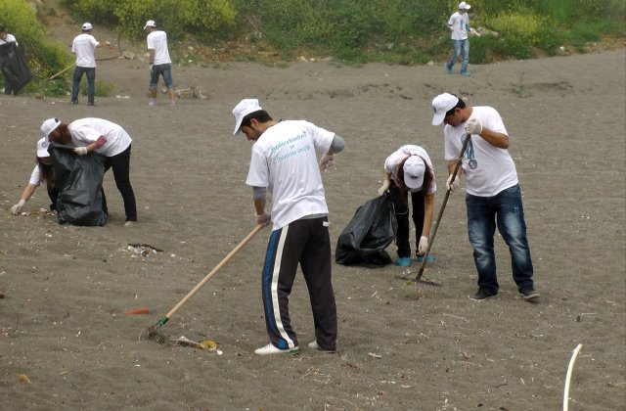

- They Cleaned Up Garbage On The Beach, 11.05.2012
Trabzon Municipality organized a cleaning campaign on the beach with the participation of approximately 600 students from 6 primary schools.
Gümrükçüoğlu, who collects garbage with the students, said that they aim to leave a cleaner and livable city to future generations with the activities they carry out with the slogan "Stop Environmental Pollution, Clean City Trabzon".

- They cleaned the Black Sea like their home Source: They cleaned the Black Sea like their home, 31.10.2009
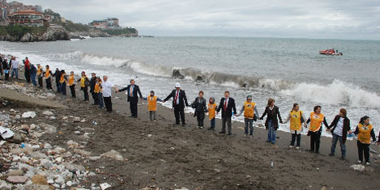
TEMA Foundation, students and volunteers collected the garbage accumulated by the sea within the scope of the International Black Sea Day on October 31st. Garbage consisted of diapers, eggshells, syringes, underwear, and drinking bottles. Garbages filled in a vehicle belonging to Zonguldak Municipality were then sent to the garbage dump.

- GEORGIA

The state of the public awareness about marine litter pollution and its impact on marine environment, especially by the river Chorokhi and its tributaries. Marine litter is a global problem that threatens the marine environment and has negative consequences for the environment, economy, society and health. Lack of public awareness and lack of communication between different stakeholders exacerbate the problem. The media is one of the key actors in raising public awareness. This report aims to review the various media sources covering the above issue and to assess the level of public awareness of the pollution of the Black Sea in Adjara Region by litter.

Methodology/Evidence acquisition:
The information was obtained by keyword researches based on the question (marine litter, pollution by the Chorokhi River, etc.) and Black Sea, pollution, waste, public awareness keywords using google and yahoo search engine from January 2017 to October 2020. Additional evidence was obtained by checking the references from the articles, found as a result of searches on Google and Yahoo. The search included articles, blogs, videos, study data and educational sources published via internet. Here is the results of the social media output on the marine litter.

  - 2017
- Batumelebi ბათუმელები, 27.02.2017, the one of the most popular printed and internet media sources for Adjara population, provides both printed and video information about the ecological condition of Black Sea. This info shares the findings of the study financed by EU and UNDP and conducted by (EMBLAS), According to those findings toxicity of some substances in the Black Sea exceeds the permissible norm. As it was above mentioned, the info contains a video source uploaded on Youtube.com https://youtu.be/ocDgtJLkcGs. Video has 2,548 views; On the contrary, published information has no comments or recommendations. https://batumelebi.netgazeti.ge
- UNDP Georgia Press release: May 23, 2017. The Black Sea has been damaged by human activity, according to a study by the European Union (EU) and the United Nations Development Program (UNDP). This is a title of press release of the presentation the presentation of the results of a large-scale Black Sea environmental study on the meeting held in Tbilisi. The joint Georgian-Ukrainian study was conducted with the support of the European Union and the United Nations Development Program (UNDP) in cooperation with the governments of Georgia and Ukraine and research institutes. The aforementioned press release contains information on unique observations made during the monitoring, including a general study of water pollution and detection of major contaminants, a study of changes in the oxygen layer of the Black Sea, etc. https://www.ge.undp.org.
- Imedinews. 11 October 2017. “How polluted is the Black Sea; Monitoring results and plan”. Interview with researcher Archil Guchmanidze; the head of the Black Sea Monitoring Service, answered on the questions of Maestro TV about alarming ecological situation in the Black Sea basin and overviews the findings of the study conducted by the National Environment Agency (Georgia). https://imedinews.ge
- Liberali ლიბერალი, 25 June 2009, within the title: “Black Sea is black again” publishes an article describing an alarming condition on the Black Sea coasts. Discussing the dangerous situation Liberali is speaking mostly about sewage system and dirty water entering the sea from the collectors installed on the beaches and provides an information taken from the Batumi City Hall, according to which 130-150 thousand cubic meters of sewage water flows from the city into the Black Sea every day. In addition, provides an evidences from different sources. This blog has no comments, but it is shared 71 times. http://liberali.ge
- Radio FM Fortuna; 26 June 2017. Radio Fortuna informs listeners that the holiday season in the Black Sea can be dangerous due to sea pollution, describing the cleanest and most polluted places on the Black Sea coast. This information is obtained based on the study findings conducted by the professors of Ivane Javakhishvili Tbilisi State University Institute of Geology https://fortuna.ge
- Regio Info, 10 October, 2017: provides readers with similar information describing three cases of pollution of the territorial waters of Georgia by a ship, identified by officers of the Conventional Division of the Black Sea Protection of the Department of Environmental Supervision in conjunction with the border police. An interesting fact is that this information read 3111 reader. https://reginfo.ge
- TV and video-stories, 2017: In 2017, several stories dedicated to the environmental problems of the Black Sea were found on television, most of them have been showed by Imedi TV, one –by internet TV MYVIDEO.
- Imedi TV ტვ იმედი, 21 August 2017. 7Contaminated waste on the Black Sea coast, https://www.imedi.ge. Published study results on Polluted Black Sea More Than Expected - "Risk Factor" 20 June 2017 - https://www.imedi.ge/ge/video. Solid Waste and Toxic Metals in the Black Sea - Disturbing Footage from the Black Sea Coast https://www.imedi.ge/Mkari narchenebi.
- MYVIDEO TV, 27 February, 2017, the fact of pollution of Georgian territorial waters has been revealed https://www.myvideo.ge/v/3173210. Viewed 79 times.
- Georgian Public Broadcaster, პირველი არხი, 28 July, 2017. Polluted Black Sea, https://youtu.be/SGBcxc-EwVY has 147 views.

None of the TV stories had comments or shares from viewers.Better condition was found on YouTube channel. There have been uploaded some amount of visual evidences of marine litter.
- https://www.youtube.com. The authors of these stories are various TV-media sources. The stories have a very few number of viewers except one video, uploaded by სტუდია მონიტორი Studio Monitor, with the title “Black Sea and rivers - polluted environment” https://youtu.be/SqU6x9cit6Y. This story is uploaded in May, 2015 and has 7,343 views.
- Considering that the stories provided by the central TVs have no views, quite satisfied number of views has a YouTube story made by the regional, Adjara TV about Chorokhi River and its ecological problem https://www.youtube.com/watch?v=G6Um1XiXgfg. The story, told on August 3, 2016 by the author of a regular program on environmental issues, received 401 views.

  - 2018
- Ajara TV & Georgian Public Broadcaster; 6 March, 2018 presents a story about a household waste in the river Mejinistskali, Adjara. This story is posted on Facebook https://ka-ge.facebook.com/AjaraTV/posts/1636079153134971, it has one comment and is shared by one viewer only. This video is no longer possible to watch, because of error 404 (not found).
- Liberali ₾იბერალი, 29 April, 2018 publishes an article “How to reduce Black Sea pollution by plastic”. It shares a results of EMBLAS project “Improving Black Sea Ecological Monitoring” with an audience. An author provides the links of the findings http://emblasproject.org/archives/2906, Despite that there are no comments about an article, still the story was shared by the 139 Facebook users.
- National Geographic Georgia, 15 November, 2018 in the article “Black Sea” provides a brief overview of the study results conducted by the Georgian scientists. An article indicates that Georgia's waters are polluted with zinc, nickel, lead and other heavy metals. The average amount of metals listed above is about 1.5 times higher than the allowable limit in the Black Sea. In addition, highlights the findings of a water analysis that the wastewater in the sea is significantly contaminated with bacteria, which is a serious health concern. According to the article, the Chorokhi River used to carry more than half of the solid sediment imported from the territory of Georgia into the sea. This figure has been reduced by 9 (nine) times today. https://nationalgeographic.ge/shavi-zghva/.
- Batumelebi ბათუმელები, 21 November, 2018. Presents an interview with Project MARLITER Coordinator, Nino Tskhadadze, this joint project was implemented by five Black Sea countries: Bulgaria, Romania, Greece, Ukraine and Georgia, the project aims to learn how the Black Sea is polluted and what part of the water is polluted with waste. Participants will create an online platform to collect, upload and disseminate evidence and information to users and stakeholders. The site will be ready by January 2021. https://batumelebi.netgazeti.ge/news/169530/. The article has no comments or likes.

TVs and video-stories;
- Ajara TV, 19 February, 2018 about the fact of pollution of the Black Sea with oil products has 1571 views. https://www.ajaratv.ge/article/26078.YouTube, 5 November, 2018, “Protecting the Black Sea”. Story uploaded by the person who has 91 subscribers, has only 11 views. There are no comments. https://youtu.be/ PUZzgyD9dPI This story also was provided to the listeners by radio Zveli Kalaki. This is a regional radio situated in Imereti region of Georgia. The second largest river of Georgia, Rioni crosses Imereti and other regions and flows into the Black Sea. On the site of the radio Zveli Kalaki the story has only one recommendation. http://www.radiodk.ge/akhali-ambebi/sazogadoeba/article/18065-shavizghvisdabindzurebisdonekvlavmaghaliashavizghvisdacviskvireuliquthaisshi

3.3.2019
- EU NEIGHBOURS east; 30 April, 2019; writes about Black Sea plastic pollution and tries to find solutions on how harm can be reduced; https://www.euneighbours. eu/en/east/eu-in-action/stories/black-sea-contaminated-plastic-how-can-we-reduce-damage .
- GHN (Georgian News Agency), 31 July, 2019, Provides readers with information that according to EU the Black Sea is twice as polluted as the Mediterranean Sea.
- Rioni.TV, 11 July, 2019 the story about Project "Rivers without Waste - Clean Black Sea" has only 53 views, there no comments. http://rionitv.com/index.php?newsid=8511 . This information had been viewed by 2472 readers, surprisingly there are also 170 FB likes. We assume that the reader confirmed that they are “sharing” the scare about the dangerous condition of the Black Sea.
- The most “popular” video story “The Black Sea has turned into a garbage can - a Batumi landfill in a BBC report” reposted from BBC News official Facebook page https://www.facebook.com/watch/?ref=external&v =1049424978726664 by newsreporter.ge, 29 November, 2019 https://newsreport.ge/shavi-zghva-nagvis-yuthadaa-qceuli-bathumis-nagavsayreli-is-reportazhshi/ In this video report of a BBC journalist is speaking about the alarming condition of the Black Sea. The first footage shows the Batumi landfill. It was not surprise that BBC News on FB had 2.4kb viewers and 189 comments, while on ewsreporter.ge were no comments; we should mention the one very important passage from a story. The reporter of BBC news visited Georgia, particularly, Batumi, Adjara. On her questions to the vacationers, are they worrying that polluted sea negatively affect their health, they are ignoring danger "This is nonsense, what kind of pollution are you talking about? I will still swimming everywhere”….
- November 20, 2019: EMBLAS-Plus Projects: On the web of this international organization is published brief description with the illustrations and figures about the joint project “Marine litter monitoring in the Georgian section of the Black Sea”. According this information “Iv.Javakhishvili Tbilisi State University (TSU), in accordance with the planned activities within the project “Research studies on contaminants ( MSFD Descriptors 8 and 10) in the Georgian section of the Black Sea” (EMBLAS-Plus) carried out the second field survey on collecting and analysis of beach/riverine/marine floating litter in the Georgian section of the Black Sea. Survey session was held from 25 of September to 2 of October, 2019.” Monitoring area included 5 sites, Maltakva, northen periphery of Kobuleti, Thskaltsminda, Sarpi and Ureki. There is mentioned that this action was a second stage of above project. As a results, participants found that the main part of plastic litter is composed by drinking bottles, caps/lids and different size of plastic pieces and the total amount of litter is decreased compared with past years. http://emblasproject.org/archives/3615

3.4.2020
- Mtavari TV, 25 June, 2020, in the news talks about the possible risk of a coronavirus outbreak due to pollution of the Black Sea with used face masks and gloves. https://mtavari.tv/news. There are no statistics on viewership, but considering that Mtavari TV is one of the mainstream TV channels with a high rating, in addition, this news was provided in the prime time news, we can assume that this information was watched by many people, at least fans of Mtavari TV News.
- VOA, Voice of America; 30 July, 2020 illustrates” flowering” of the Black Sea and the most dangerous threats to the environment. https://www.amerikiskhma.com/a/black-sea-ecological-situation-shows-to-be-desasterous/5523236.html#comments. The information is confirmed by visual evidence in the form of a short video. The information appears to be posted on the Facebook forum, but there are no comments.
- TV25 Georgia, 30 July, 2020 provided same information in form of TV-news. https://tv25.ge/news.php?lang=ge&id=23183 On the TV25’s portal 6 viewers watched this news. Video is uploaded on YouTube channel where has 101 views. Should be noted that TV25 is regional, Adjara television.
- Public Broadcasting of Adjara, 7 October, 2020 talks about the exercises of specialized structures under the Under the National Oil Spill Response Plan. https://ajaratv.ge. on the portal of public broadcasting the news watched 179 times.
- AllNews.ge, 11 October, 2020 acquaints readers with the most polluted places of the Black Sea with the recommendations for visitors how to avoid pollution and protect coasts. https://www.allnews.ge the blog has no comments. No information about the viewers.

- ROMANIA
Marine litter (ML) is a global challenge and society plays an important role via habits, traditions and culture. In this report we provide an overview of public perceptions of litter and marine litter and contributing factors at local and national level in Romania. We focus on responses from the general public rather than all stakeholders to find new insights into how the Romanian public perceives and responds to the issue of litter in general and marine litter in particular.

Since ancient times, man lived in communion with nature and through the activities undertaken, he used only what was strictly necessary, the few wastes being reused, with various applications, as natural fertilizer, animal feed or as popular natural remedies for various ailments. The Romanian culture and traditions are closely related to cleanliness habits, that bring prosperity and luck to those who respect them. In folklore, the hard-working man, who keeps his house neat and clean, is seen as a model for his community.

Romania has many traditions and superstitions in folklore regarding cleanliness, closely related to the religious customs of this country. On holidays it brings bad luck to work the field or to clean the house, for example, on St. Parascheva’s Day, according to the popular believes, the girls who wash, clean the yard or the house, will remain unmarried (https://playtech.ro/stiri/). On the day of the Holy Ascension, it brings bad luck if washing, cleaning or other field works are performed (https://www.capital.ro). On the first day of spring, cleaning or washing are not recommended, as not to bring back the frost of the winter and not to drive away the luck of the house (https://www.la-doi-pasi.ro). For Dragobete, the Romanian Valentine’s Day, although some activities such as weaving, sewing or other household chores are forbidden, cleaning is allowed in order to attract a year full of freshness and growth (https://blog.travelminit.ro). In Moldavia region, on the first day of Easter fasting, women clean the whole house and especially the kitchen with a mixture of lye and water, to remove any traces of animal fat that would affect the purity of the dishes (http://occidentul-romanesc.com). Among the superstitions regarding cleanliness, it is not recommended to throw the garbage out of the house in the evening because the popular belief says this will lead to the loss of the wellness of the house; this also foretells the arrival of a stranger in the house (http://occidentul-romanesc.com). In Banat region, there is a tradition of washing all the family's clothes with lye, before entering the Easter fasting period (Fig. 1.) (http://occidentul-romanesc.com).

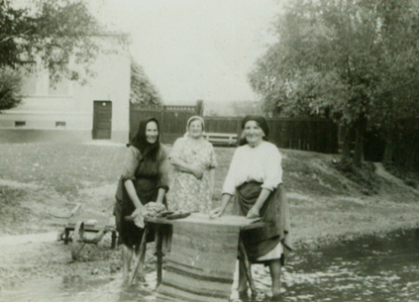
Fig. 1 Women washing clothes with lye in Banat region of Romania (http://jurnaldemandra.blogspot.com/2011/07/la-vale-la-spalat-haine.html
)

In Transylvania region, households and gardens are prepared through a general spring cleaning, the resulting garbage being lit at the Martyr’s Day or Annunciation’s Day, the fires made with them also having magical meanings of purification and defense of people and households from diseases and evil spirits (http://occidentul-romanesc.com). A few days before Christmas, in each house there is a general cleaning, a cleaning that symbolizes the expulsion of evil spirits and the reception in purity of the baby Jesus (https://lecturisiarome.ro). On the New Year’s Day, Romanians do not throw the garbage, this being considered a sign of poverty in the year that is just beginning (https://www.digi24.ro).

In Romania, the consumption behavior forced by a "rational diet" (rationalization of the basic foods) practiced during the socialist era (1948 –1989), made the people to paid more attention on how to use and not waste it (https://www.estidiniasi.ro). The waste also became a key issue around which the population was mobilized in that time. The communist slogan "Recovery, recycling, reuse" urged the population to a rational consumption, traders were offering the possibility that, when purchasing products, the buyer could exchange empty bottles and jars without paying extra (Fig. 2.) (https://www.estidiniasi.ro).

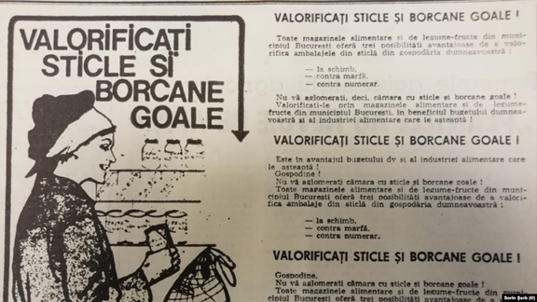
Figure 2. Communist advertising on recycling empty bottles and jar (https://romania.europalibera.org/a/buletin-de-%C8%99tiri-22-iulie-1989/30067595.htm)

With the fall of the communist regime and the advance of industry and technology in the 21th century, the products on the market have been diversified in Romania following the linear economy models based on “take, make and dispose” which lead to an increase in consumption directly proportional to the amount of resulted waste. However, this has generated much more waste on the planet that doesn’t break down by itself. But the problem of litter is also structural. Many of the objects we use now are made from non-biodegradable material and destined for one use. And everything is wrapped and wrapped again, swathed in unnecessary packaging. Certainly, part of the explanation for this rising tide of rubbish is behavioral and generational. Each generation has its own littering habits that set them apart from one another. Those who have grown up in a disposable society have a tendency to, well, dispose. This process is in fact a challenge to societies all around.

One of the biggest issues facing Romanians today is waste recycling. Neglecting to properly select and sort their waste, Romanians from urban area opt to toss everything in the same bin, causing great problems. Rural communities face similar changes nowadays due to the lack of proper collection and storage. Thus, most of the waste, including plastics and other materials that could easily be recycled, ends up in legal or illegal landfills. This is a country wide issue that needs to be urgently addressed as Romanians are so concerned about waste pollution in their country.

Waste actively contributes to pollution and pollution related illnesses/deaths, especially when it is left in water. Pollution affects the local ecosystem, livelihoods based off of the land, and human health. Global studies have shown that 80% of marine litter comes from land and the Black Sea makes no exception (https://www.eea.europa.eu). Similar to other countries bordering the Black Sea, the accumulation of marine litter on the Romanian beach as well as along the coast and in the sea has recognized as a big problem since the mid 1990ies (Fig. 3). Since then, location and abundance of litter on Romanian beaches and along the coast is most visible and the public is aware of it. There is increasing evidence that Romanian people report high levels of concern about marine litter, mostly by seeing litter when visiting the coast.

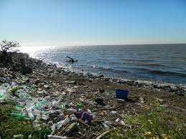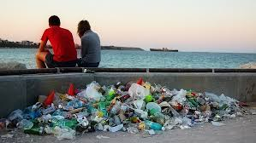
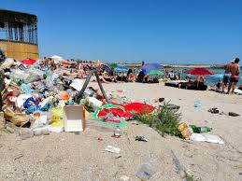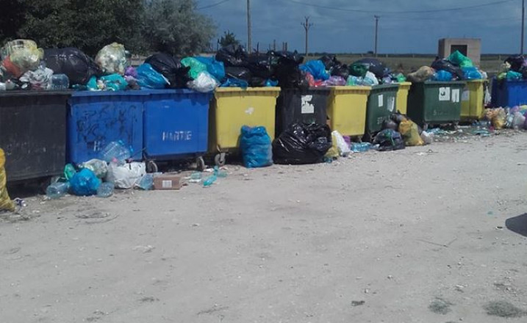
Figure 3. Marine Litter at the Romanian Black Sea shore

The marine litter issues and plastics pollution has become part of the mainstream of traditional and social media in Romania over the last years. Several environmental NGOs have as main theme of activity, education and awareness of the population regarding the issue of marine litter in Romania (Fig. 4) and also organize regularly clean-up activities of the environment in collaboration with volunteers, local authorities and other stakeholders.

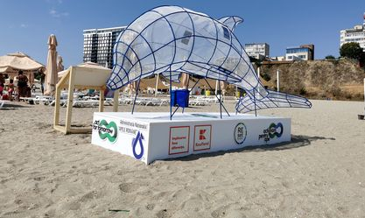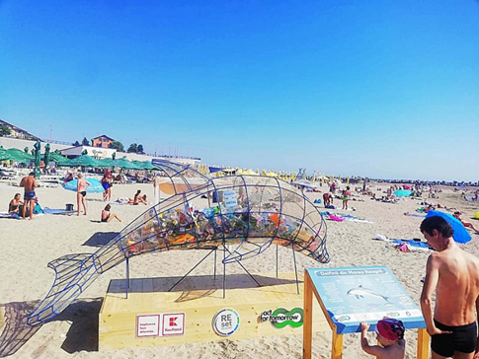
Figure 4. First collection infrastructure in the form of gigantic marine animals
launched in Romania in 2020 by the Act for Tomorrow Association & Kaufland Romania

Romania is part of the international cleanup campaign “Let’s do it” which aims to unite the global community, raise awareness and implement true change to achieve our final goal – a clean and healthy planet. Thus, 15 of September is declared the Romania Cleanup Day. In 2018, more than 365 000 volunteers gathered 3505 tons of waste, cleaning 1.502.455 m2. In Constanta, 2600 volunteers took part at the action and have collected 3000 bags with waste.

Starting with 2017, Romania joined the challenge “Plastic free July”, an international concept of awareness, change and mobilization of community to protect nature from the effects of plastic, where millions of people give up single use plastic during the month of July. Plastic is used daily, in the form of bags, bottles, packaging and many more. Sometimes people use plastic for only a brief moment to carry groceries home or to drink a cup of coffee, but it can take up to 1000 years to decompose. Plastic is destructive for the environment; it lowers the fertility of our soils and is harmful for wildlife. More plastic has been produced in the first ten years of this century than its predecessor.

Mare Nostrum NGO marks every year the Black Sea International Action Day by organizing public campaigns to inform local community, coastal communities, authorities and the general public about the importance of marine and coastal ecosystems for local and regional development and the problems that may arise there. Starting with 2016, Mare Nostrum started to organize a running which aim is to raise awareness of the impact of marine litter. Thus, there are 3 routes: one for children and their parents, one of 4 km and one of 7 km. The number of participants increases from year to year and in 2018, 1500 runners accepted the proposal, to run for the Black Sea.

- BULGARIA
The traditional cultural perceptions of Bulgarians reflected in folklore associate the beauty of nature and its value for man with clear cold water. This stark image often appears in combination with the green forest and fields in songs and ballads. In folk tales about everyday life a clean and tidy home is a source of pride for every housewife. The Bulgarian cultural traditions have deep roots and have been preserved to this day. Life in the old days was more frugal and people used resources, including water, rather sparingly. They produced very little waste and tried to utilize it for feed of the livestock or improvement of the land.

The advance of industry and technology in the 20th century brought about mass production, affluence and the use of plenty of resources (among them water and oil, that are essential for the production of plastics) following the linear business models based on “take, make and dispose”. People began to produce too many articles, often for short or single use, and to discard them easily so that they became waste and the waste started to accumulate on land and found its way into the sea. We are now looking to circular business models based on reuse, resource efficiency, the sharing economy and closed loops. This can counteract resource depletion, reduce pollution and be a source of cost reductions, new revenue streams and better risk management for producers. This process is a challenge to societies in the Black Sea countries.

The traditional Bulgarian perceptions about cleanliness and the beauty of nature however remain. They are reflected in the messages about the Black Sea and its environmental issues, including pollution with marine litter. ‘Clean’ is present in many names of campaigns and slogans of activities. National campaigns ‘For clean water’ ‘Clean coast’, ‘Clean beaches’, ‘For Clean Environment’ have become regular annual events, held by government institutions or environmental organisations with media support.

The messages about the environmental state of the Black Sea and the concerns over its future make no exception. They put an emphasis on the cleanliness of the sea and the coast. Since the mid-1990s beach clean-ups have been organized by environmental NGOs and concerned citizens as an awareness raising effort to protect the Black Sea. The Black Sea NGO Network is conducting social media activities associated with marine litter profile on Facebook entitled ‘For a clean coast and a living sea’ and a second open Facebook group named ‘United for a clean coast and a living sea’. The titles were selected by opinion survey and rating by a focus group of regular participants in beach clean-ups, volunteers of environmental NGOs.

Concerned citizens and environmental activists, educators, scientists, experts all agree that the wasteful consumer habits and the production of large amounts of waste have to be corrected with campaigns and activities and good practices supporting the correct environmental policies regarding waste and marine litter. Those campaigns will support the traditional Bulgarian appreciation for clean waters and clean environment and will seek to correct consumer behaviours and public policies of waste management.

  - Reaction Of The Public On Litter And Litter Problems.
The baseline assessment of Bulgarian stakeholders’ state of awareness about marine litter relies on expert opinions and the findings of some surveys and other tools employed over the years by the Black Sea NGO Network. It provides an overview of experience and projects implemented, assessment of stakeholder attitudes and engagement and an account of marine litter related activities and messages put across to the Bulgarian public.

  - Stakeholder Identification And Mapping.
About 12 million tons of plastic are expected to enter the oceans each year. European Member States that are aware of the problem are increasingly involved in environmental protection schemes to combat the growing spread of marine litter and to encourage fishermen from all over Europe to take part in recycling and cleaning initiatives.

The Black Sea NGO Network has good knowledge of the national and regional stakeholders related to the marine litter issue both on national level and in the Black Sea Region. BSNN has a database of over 90 Bulgarian and regional institutional stakeholders. It is the product of the BSNN experience described below.

The organization has long record of cross-border cooperation with partners in the region in environmental education, awareness raising activities, expert involvement and cooperation with scientific and educational establishments, addressing decision makers and authorities on local, national and regional level , environmental protection and campaigning with funding or with volunteer involvement , including marine litter reduction campaigns http://www.bsad.bsnn.org/home.htm marking the 20th anniversary of International Black Sea Action Day October 31, 2016 on regional and national level. BSNN in its daily activities manages and implements projects on national and cross-border level, organizes training, publicity and media events, meetings, workshops, conferences, expert work, publications, networking. BSNN areas of thematic competence include regional, national and EU environmental policies, Black Sea issues and policies, international water management issues, Black Sea and international biodiversity protection, Natura 2000 sites, sustainable development, coastal zone management, data collection and management, production of databases of good practices, environmental governance, environmental education, youth involvement, civil society development, stakeholder involvement, advocacy and lobbying.
Projects implemented by BSNN are available on its website and subpages from links on project lists both in English and Bulgarian. The projects most relevant to the marine litter issue are the following:

- PERSEUS ‘Policy-oriented marine Environmental Research for the Southern European Seas’ 7FP of EU, focused on MSFD - involved in adaptive marine policy issues, assessing the dual impact of human activity and natural pressures on the Black Seas, citizen science and production of Marine LitterWatch app for beach litter monitoring http://www.perseus-net.eu/site/content.php;
- 'Reduction of litter in the marine and coastal environment and sustainable use of natural resources Marine Litter Watch' – FM of EEA, Bulgaria – involved in training of youth, campaign for marine litter reduction and publications including guide on best practices in reduction of marine litter http://mlwatch.bsnn.org/materiali.html;
- Stakeholder consultations on the preparation of the Bulgarian Marine Strategy on national level –supported by EU and the FM of EEA under projects like MISIS, ISMEIMP, MARLEN, etc. and provided input to the Programme of Measures for Descriptor 10, marine litter for improvement of national and regional measures;
- Awareness Campaigns under project “Clean rivers Clean Sea: NGOs actions for environmental protection within the Black Sea area”—JOP BSB 2007-2013 with strong focus on MSFD and clean beaches with materials both in Bulgarian and English (see References);
- MELTEMI - MarinE litter transnational LegislaTion EnhanceMent and Improvement – with partners from Greece, Bulgaria, Cyprus and Albania with focus on adaptive policies for marine litter.

According to the MELTEMI (MarinE litter transnational Legislation Enhancement and Improvement, INTERREG V-B ‘BALKAN MEDITERRANEAN 2014-2020’) project the active engagement of the society and the key-players by informing, educating and networking them on a science and policy assessment framework of marine litter were realized. The key actions that have been foreseen for engaging the society in taking measures against marine litter are: Meltemi@School, Blue Cafes, Information Centers and Stakeholder training. Projeci MELTEMI activities: Month of monitoring of marine litter on the beach after the start of the tourist season https://www.bluelink.net/novini/mesets-na-monitoringa-na-morskite-otpadatsi-po-plazha-sled-nachaloto-na-turisticheskiya-sezon 15.09.2020.; The public in Varna will fight against marine litter, https://uspelite.bg/obshtestvenostta-vav-varna-shte-se-bori-sreshtu-morskite-otpadatsi-1 , 7.12.2018; Interviews on Meltemi in the national media concerning marine litter: https://www.chernomore.bg/morski-biznes/2020-02-24/zakonovi-promeni-shte-namalyat-pritoka-na-otpadatsi-v-moreto;https://news.bg/bulgaria/cherno-more-bilo-ekologichno-neblagopriyatno.html; https://agrozona.bg/8-organizatsii-iskat-normativni-promeni-za-borba-s-morskite-otpadatsi/; https://petel.bg/m/idex.php?action=view&id=350552&opinion=; https://bntnews.bg/news/cherno-more-e-ekologichno-neblagopriyatno-spored-nepravitelstveni-organizacii-1063203news.html; https://bnr.bg/play/post/100972665/morskite-otpadaci-tema-na-diskusia

Marine litter is a global challenge and society plays an important role via lifestyles and behaviour, including policy support. Organizations from 4 countries want regulatory changes against the marine litter https://www.chernomore.bg/a/7-morski-biznes/196948-organizatsii-ot-4-darzhavi-iskat-normativni-promeni-za-borba-s-morskite-otpadatsi, 19.02.2020

- MARLITER "Improved online public access to environmental monitoring data and data tools for the Black Sea Basin supporting cooperation in the reduction of marine litter'' encouraging the use of open data and data tools for marine litter monitoring and reduction.
- European fishermen are taking the lead in marine litter, https://flag-burgas.org/evropeyskite-ribari-poemat-vodeshta-rolya-za-morskite-otpadatsi/, 25.04.2018; Fishermen want landfills to collect waste from the sea, https://www.maritime.bg/68456/ 15.07.2020

The various stakeholder groups of the project are familiar to the BSNN and the partner is well prepared to involve them with the relevant tools and messages in awareness raising.

  - Awareness and acknowledgement of the issue by the stakeholder groups
The stakeholder groups engaged in the project are generally aware of the problem and acknowledge its importance for the environment, human health and society. There is evidence about that awareness over the years. In 2007, when marking the 10th anniversary of International Black Sea Day, the BSNN carried out a survey among stakeholders to identify Black Sea problems. Solid waste pollution of beaches and the coast was among the top problems listed by the stakeholders. The choice of beach clean-up as focus of awareness raising campaigns since 1996 is indicative of the regional public’s attitude to marine litter issues. With EU accession and implementation of the Bulgarian Marine Strategy under the EU Marine Strategy Framework Directive (MSFD), marine litter issues became part of the Bulgarian Programme of Measures. The number of projects targeting marine litter since 2008 have involved environment authorities and agencies, national and local authorities, environmental NGOs, education institutions on all levels, scientific research institutes and the public. Coverage in the media and social media is regular and covers various aspects of the marine litter issue. In the Facebook group ‘United for a clean coast and a living sea’ people have been sharing between 60 and 80 publications per month over the past two years and the group has over 900 followers from coastal places. Beside Bulgarian NGOs, international campaigners like Greenpeace, Surfrider etc. with their branches in Bulgaria have conducted targeted marine litter activities.

The experience of BSNN with several projects and campaigns has proved that waste companies, recyclers and the maritime businesses are difficult to involve in awareness activities and stakeholder dialogue.

The awareness of groups like environmental NGO activists, scientists, education experts, young people and schoolchildren, environment agency experts, some municipal experts etc. is high and they recognize the issue as very important for society and for them personally. Those stakeholders recognize the importance of bringing together various stakeholder groups with interest in or responsibility for solving the problem of marine litter abatement.

Representatives of the maritime industries and businesses, sectoral agencies (public waste utilities, waste management companies, recyclers) and tourist businesses and service companies are generally aware of the problem. They are however more difficult to involve in awareness activities and cooperation with the other stakeholder groups.

  - Perceptions On The Abundance And Location Of Marine Litter
Marine litter is visible on beaches and areas close to the coast. Its abundance there is considered as an issue by all stakeholders. Some stakeholder groups like NGO activists, teachers, scientists, young people and concerned citizens of all ages have expressed their worries about the quantities of waste on the beach obviously left there by tourists, beach visitors, customers of beach cafes and bars. Quite a number of coastal municipalities have plans for cleaning the beaches and even plan to obtain technology for the purpose. Students, teachers and activists taking part in the citizen science activities of BSNN since 2014 have repeatedly expressed concern over the large numbers of cigarette butts, that they record. Their numbers of litter items on popular beaches are quite high after the tourist summer season compared to early spring monitoring results.

The abundance of specific litter items, mostly smoking related and single use plastic items, influence Bulgarian stakeholders’ perception of marine litter. Quite a few of them believe there is a lot of litter on the beaches. That is certainly not true of all beaches in Bulgaria as there are some very clean areas, mostly away from crowded cities and beach resorts though plastic pieces and other litter in small numbers can be found on every beach and coastal space.
Currently the EU Technical Group on Marine Litter is working on indicators for good environmental status for beach litter to help establish a standard and baseline and set targets for improvement of the state of coastal marine litter pollution.

Floating macro litter and litter in the water column are familiar to users of the marine waters, both for bathing, diving, recreational and business purposes. BSNN has produced a documentary film about litter entitled ‘Letter in a plastic bottle’ with author Tsvetelina Atanasova, in which scuba divers, surfers and activists account of their experience with floating litter items, on the sea surface and in the water column. Cleaning of sea port areas and navigation canals brings to the surface various household, technical, construction and other items and pieces that have been lying on the seabed.

Marine litter on beaches and areas close to the coast is visible and perceived to be a quite lot and requiring action from the authorities and society. Litter in the sea and especially on the shelf is less familiar to stakeholders as they cannot see it. Micro litter and litter ingested by marine wildlife are less familiar to the stakeholders for the same reason.

  - Perceptions of the causes and consequences/risks of marine litter
The Bulgarian public awareness has been influenced by various projects associated with information and education about sources and pathways of marine litter. Plastics pollution has been the special focus of marine litter awareness activities. Traditional and social media provide regularly plenty of information and examples of the plastics pollution in the ocean. A simple Google search for ‘plastic waste in oceans’ gave over 53 000 results in Bulgarian; a similar search in Bulgarian for the Black Sea produced 72 500 results; a search in English for ‘plastic litter Black Sea’ has produced 11 300 000 results. The EU related waste legislation such as the Packaging Waste Directive, Single Use Plastics Directive, the Circular Economy Package and initiatives like Zero Waste Europe, Rethink Plastics etc. have been covered regularly by the Bulgarian media. The coverage has provided a specific emphasis on the issue of abundant plastic waste influencing all components of the environment, including waters and marine waters.

The consequences of marine litter pollution for the marine environment, economy and safety as well as human health have been covered regularly. In the weeks preceding International Black Sea Day 2020 every TV with national coverage, as well as all social media provided information, at least two reports, on marine litter pollution sources and problems. The BSNN Facebook profile focusing on marine litter in the period before 31 October has increased the number of followers by over 200 and 13 volunteers took part in Black Sea photography sharing activities.

The Bulgarian stakeholders’ understanding about litter impact on their living environment and their health in particular is associated with information from media coverage, environmental information and education campaigns. Litter on the beach is usually perceived as an aesthetic issue and only is less often directly associated with a threat to human health. The threat to safety of bathers in the sea, swimmers, divers, surfers is less familiar to stakeholders. Micro litter accumulation in seafood and its influence on human health is perceived as a health issue as well. Ongoing research on microplastics and marine litter is going to raise awareness of stakeholders.

The Bulgarian stakeholders are generally well aware of the causes and consequences of marine litter pollution, especially plastics pollution, as the issue has been mainstreamed in the Bulgarian media. The sources and pathways of litter are more specific and need to be further elucidated to the individual stakeholder groups, especially in relation to the marine litter management practices, policies implementation, site-specific solutions and personal consumer habits and behavior. Micro litter accumulation in seafood and its influence on human health is perceived as a health issue and there is need to provide new research data and evidence about it to motivate informed decisions about personal habits and attitudes, as well as public policies.

  - Perceptions About Responsibilities And Involvement In Solutions To The Problem
The perceptions of various stakeholder groups about responsibilities and solutions to the marine litter issue vary a lot. There is general understanding that the problem is complex and needs the attention of authorities on all levels, from local to national and basin level. There is a demand from the Bulgarian wider public for better enforcement of regulations on environmental legislation and it is putting pressure on the government to improve the situation.

Individual and group perceptions about who should take the leading role for addressing the marine litter problem and more specifically who is responsible, competent, and motivated to take action to abate marine litter pollution may vary a lot in every partner country and Bulgaria is no exception.
The understanding of multi-stakeholder involvement and co-responsibility for marine litter pollution is put across to the Bulgarian public and other Bulgarian stakeholders by representatives of environmental NGOs, scientists, education experts. The representatives of those groups are more likely to take action and change personal consumer habits, demand accountability for public policies, and support measures to abate marine litter pollution. Young stakeholders, especially schoolchildren are more likely to adopt new consumer habits and be motivated to change of attitudes. Quite a number of environmental education projects in Bulgaria target youth and children. BSNN has been producing education materials for schools as well.

Some individuals are likely to believe the government is the only responsible for reducing marine litter, whilst perceiving that they are not highly competent or motivated to act on the issue. Certain stakeholder groups – businesses, sectoral agencies, tourist companies, administrations – are less likely to take responsibility or initiative for introducing marine litter abatement measures. Centralized government institutions and their regional (sub-national) agencies have been assigned with specific responsibilities by the environmental policy legislation. They need to initiate coordinated activities and apply concerted approach of which there are not sufficient examples in Bulgaria.

The varied perceptions of national stakeholders about responsibilities, initiative and competence to achieve solutions to the marine litter issue need special attention and individual approach to stakeholder groups in terms of raising awareness on marine litter issues.

CONCLUSION

Population in the coastal area of the Black Sea have traditionally, culturally, economically and aesthetically belong to the Black Sea. The sea serves as a food source of the inhabitants, a tool for joys and also bin for the collecting their wastes. They well known that this sea is alarming either diminishing its natural resources or drown with their pollutants. Inhabitants around the Black Sea, like the global awaking, understand that they must something to save their sea. Generally, awaking starts with scientist, decision makers, NGO and finally inhabitants. We are in the crossroads to our action the folks to save our Black Sea that we have already had legal background such as laws, legislations.

Traditional habits and culture in Bulgaria support modern day environmental policies and measures advocating waste reduction and prevention of pollution at source with involvement of various stakeholder groups. National and EU related projects and campaigns have put the topic of marine litter in the mainstream of news and reports on traditional and social media and have involved individuals and institutions in marine litter activities. The Bulgarian stakeholders therefore are generally well aware of the marine litter issue and believe it is time to take measures to address the issue. They have basic awareness of the causes and consequences of marine litter pollution, especially plastics pollution, as the issue has been mainstreamed in the Bulgarian media and targeted by a number of campaigns, projects, education activities. The sources, pathways and influence of marine litter and marine litter management practices, policies implementation, site-specific solutions and personal consumer habits and behaviour are more complex and have been addressed partly by some national and cross-border projects. The Bulgarian stakeholders are aware of the complexity of the issue and have different perceptions of responsibilities, initiative and competence to achieve solutions to the marine litter problem. Extending the dialogue between stakeholder groups that have responsibilities for and interest in addressing the issue is regarded as a challenge to all partner countries.

Based on the data and evidence provided, we believe that, in general, the problem of pollution of the marine environment and the disastrous condition of the Black Sea is an interesting topic for the both regional and central Georgian media. On the contrary, public interest is very low. This assumption provides us with the basis for recommendations that we need to change the way we communicate with the society and develop new strategies to raise public awareness of marine pollution and potential environmental, social and health risks.
Generally, the traditional Romanian habits and culture support the present-day environmental policies for promoting waste reduction and prevention of water pollution. There is clear evidence that at the present time the most Romanians are concerned about waste pollution and marine litter in their country. The improper waste management vastly impacts the marine litter pollution in Romania nowadays. The country needs urgent measures to be taken by the local and central authorities in order to stop the ecological disaster that the waste disposal is causing to the rivers and waters. Beside from littering and recycling behaviors, influencing people's consumer behavior is becoming priority in Romanian environmental and consumer policy. The general public plays an important role in addressing marine litter in Romania through their lifestyles and consumption patterns, waste management practices, and support or other engagement in the implementation of policies aiming to address marine litter such as the plastic bag directive (European Directive 2015/720/EC). Therefore, understanding public perceptions and responses to the issue of marine litter is a critical step in effectively engaging society and in developing and implementing widely acceptable solutions to reduce litter inputs into marine and Black Sea coastal system.

REFERENCES

- https://www.sabah.com.tr/gundem/2020/06/07/sifir-atik-mavi-ile-deniz-ve-kiyilardan-65-bin-tondan-fazla-deniz-copu-toplandi
- https://www.haberler.com/samsun-turkiye-de-en-cok-deniz-copu-samsun-dan-12955175-haberi/
- https://www.cnnturk.com/yerel-haberler/rize/iyidere/tulum-esliginde-sahilde-cop-topladilar-1006207
- http://www.gundem67.com/zonguldak/jandarma-ekiplerinden-cevre-temizligi-h82374.html
- https://www.aa.com.tr/tr/turkiye/karadenizin-incisinde-dip-temizligi-yapildi/1527830
- https://www.cnnturk.com/yerel-haberler/zonguldak/liseliler-sahili-copten-temizledi-987938
- https://www.kastamonuguncel.com/yasam/universite-ogrencileri-karadeniz-sahilini-temizledi-h23541.html
- https://www.sabah.com.tr/karadenizdoguanadolu/2017/11/27/tekkekoyde-cevre-ve-temizlik-konusunda-farkindalik-hareketi
- https://www.61saat.com/bolgesel/ogrencilerden-deniz-ekosistemi-ziyareti-h257291.html
- https://www.samsungazetesi.com/samsun/turmepa-atakum-sahillerini-temizledi-h372466.html
- https://arastirma.tarimorman.gov.tr/sumae/Haber/204/Denizimi-Koruyorum-Ve-Taniyorum-Projesi-Iii-Sumaede-Yapildi
- http://www.pusulagazetesi.com.tr/arsiv_32637/atanlari-utandiracak-haber/
- https://www.haberler.com/ogrenciler-karadeniz-sahilinde-temizlik-yapti-3598320-haberi/
- https://www.haberler.com/sahil-kesimindeki-copleri-temizlediler-3613292-haberi/
- https://www.turkiyeturizm.com/news_detail.php?id=23980
- http://www.urban-waste.eu/wp-content/uploads/2019/07/M19.pdf
- https://www.gov.scot/publications/marine-litter-issues-impacts-actions/pages/4/
- http://www.urban-waste.eu/wp-content/uploads/2019/07/M19.pdf
- https://www.bsad.bsnn.org/index.htm
- https://www.bsad.bsnn.org/home.htm
- http://marliter.bsnn.org/
- https://www.facebook.com/%D0%97%D0%B0-%D1%87%D0%B8%D1%81%D1%82-%D0%B1%D1%80%D1%8F%D0%B3-%D0%B8-%D0%B6%D0%B8%D0%B2%D0%BE-%D0%BC%D0%BE%D1%80%D0%B5-2235656726718855/
- https://meltemi.bsnn.org/
- http://riversea.bsnn.org/index.html
- http://www.rekimore.bsnn.org/materiali.html
- https://www.facebook.com/marliterro/
- https://www.moew.government.bg/bg/kampanii/nacionalni-kampanii/
- https://bnr.bg/vidin/post/101039595
- https://www.bezplatno.net/en/classifieds/%D1%82%D1%8A%D1%80%D1%81%D1%8F-%D0%BF%D0%B5%D1%80%D1%81%D0%BE%D0%BD%D0%B0%D0%BB-%D0%B7%D0%B0-%D0%BD%D0%B0%D1%86%D0%B8%D0%BE%D0%BD%D0%B0%D0%BB%D0%BD%D0%B0-%D0%BA%D0%B0%D0%BC%D0%BF%D0%B0%D0%BD%D0%B8%D1%8F-%D1%87%D0%B8%D1%81%D1%82%D0%B0-%D0%B2%D0%BE%D0%B4%D0%B0-1452035.html
- https://www.greenpeace.org/bulgaria/press/1397/%D0%B2-%D0%B4%D0%B5%D0%BD%D1%8F-%D0%BD%D0%B0-%D0%B2%D0%BE%D0%B4%D0%B0%D1%82%D0%B0-%D0%BD%D0%B0%D0%BF%D0%BE%D0%BC%D0%BD%D1%8F%D0%BC%D0%B5-%D0%B7%D0%B0-%D1%87%D0%B8%D1%81%D1%82%D0%B0-%D0%B2%D0%BE%D0%B4/
- https://cherga.bg/bg/v-denya-na-vodata-zapochva-kampaniya-za-pochistvane-na-vodnite-basejni/
- https://playtech.ro/stiri/obiceiuri-de-sfanta-parascheva-ce-spun-bunicii-ca-este-sau-nu-e-bine-sa-facem-213120
- https://www.capital.ro/superstitii-si-traditii-de-inaltarea-domnului-ce-nu-trebuie-sa-faci-astazi.html
- https://www.la-doi-pasi.ro/sfaturi/martisor-traditii-si-obiceiuri.html
- https://blog.travelminit.ro/traditii-si-obiceiuri-ale-romanilor-in-ziua-de-dragobete/
- http://occidentul-romanesc.com/andra-mateescu-obiceiuri-si-traditii-in-preajma-sarbatorilor-de-pasti/
- https://lecturisiarome.ro/2015/12/5-obiceiuri-de-craciun-din-strabuni/
- https://www.digi24.ro/stiri/actualitate/superstitii-si-obiceiuri-de-anul-nou-177150
- https://www.estidiniasi.ro/2018/02/05/ne-intoarcem-in-comunism-operatiunea-sticla-si-borcanul-ministerul-mediului-vrea-sa-platim-2-lei-pentru-fiecare-ambalaj/
- https://www.eea.europa.eu/ro/semnale/semnale-de-mediu-2014/imagine-de-detaliu/deseurile-din-marile-noastre
- https://business-review.eu/greenrestart/romania-face-to-face-with-marine-litter-a-visually-striking-campaign-and-the-first-waste-disposal-infrastructure-in-the-form-of-gigantic-marine-animals-on-the-black-sea-coast-212353
- http://jurnaldemandra.blogspot.com/2011/07/la-vale-la-spalat-haine.html
- https://romania.europalibera.org/a/buletin-de-%C8%99tiri-22-iulie-1989/30067595.html

